Power Series about a Singular Point

EXPERIMENT - 10

CODE: -

clear all  
clc  
syms x r c_0 d_0 c_1 c_2 c_3 c_4 c_5  
disp('Note : input the coefficients of the DE as constant or function of x')  
p1x=input('The coefficient of D2y :');  
p2x=input('The coefficient of Dy :');  
p3x=input('The coefficient of y :');  
c=[c_0, c_1, c_2, c_3, c_4, c_5];  
y1=sum(c.*(x).^(0:5));  
Px=p2x/p1x; Qx=p3x/p1x;  
px=x*Px; qx=x^2*Qx;  
a_0=subs(px,x,0);  
b_0=subs(qx,x,0);  
r=solve(r*(r-1)+a_0*r+b_0);  
for i=1:2  
y=expand(y1*x^r(i));  
dy=diff(y);  
d2y=diff(dy);  
ode1=p1x*d2y+p2x*dy+p3x*y;  
ode=ode1/x^r(i);  
end  
ps=collect(simplify(ode),x);  
d=coeffs(ps,x); [c_1,c_2,c_3,c_4,c_5]=solve(d(1),d(2),d(3),d(4),d(5),'c_1 ,c_2,c_3,c_4,c_5');  
z(i)=vpa(subs(y),3);  
disp('Linearly independent solutions are :')  
disp(z(1));  
disp(z(2));

Input 1: -

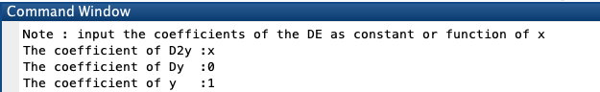

Linearly independent solutions are :

0

- 0.000011574074074038875892256328370422*c_0*x^6 + 0.00034722222222427490123664028942585*c_0*x^5 - 0.0069444444444570763153024017810822*c_0*x^4 + 0.083333333333939663134515285491943*c_0*x^3 - 0.5*c_0*x^2 + c_0*x

Input 2: -

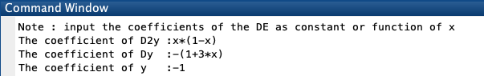

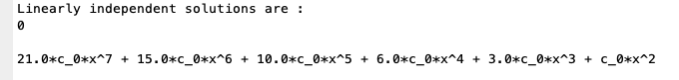

Input 3: -

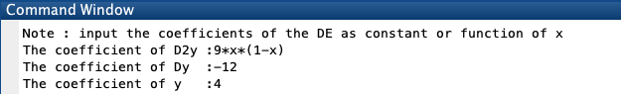

Linearly independent solutions are :

0

c_0*x^(7/3) + 0.80000000000291038304567337036133*c_0*x^(10/3) + 0.67692307692777831107378005981445*c_0*x^(13/3) + 0.59230769230634905397891998291016*c_0*x^(16/3) + 0.52995951416960451751947402954102*c_0*x^(19/3) + 0.48178137651848373934626579284668*c_0*x^(22/3)